**MIS500 – Foundations of Information Systems**

**(Assessment 1)**

**Research Report**

TOPIC

Sneaker Brand or Sneaker Retailer:

Student Name:

Student ID:

Learning Facilitator/Lecturer:

**2023 (Trimester 1)**

**Academic Integrity**

I declare that except where I have referenced, the work I am submitting for this assessment task is my own work. I have read and am aware of Torrens University Australia Academic Integrity Policy and Procedure viewable online at http://www.torrens.edu.au/policies-and-forms

I am aware that I need to keep a copy of all submitted material and their drafts, and I will do so accordingly.

**Sign your name.**

**Table of Contents**

Contents

1. Introduction 4

2. Discussion (maximum 200 words) 4

3. Audit and Analysis (maximum 300 words) 4

4. Recommendations using Porter’s Value Chain model (Marketing and Selling) (maximum 250 words) 5

4.1 Recommendation 1 5

4.2 Recommendation 2 5

4.3 Recommendation 3 5

5. Conclusion (maximum 200 words) 5

6. Recommendations (maximum 150 words) 6

**6.1** Recommendation 1 6

**6.2** Recommendation 2 6

**6.3** Recommendation 3 6

7. References 6

8. Appendices 7

**Tip – You can use the automatic Table of Contents on Word to do this, this will automatically update the headings and page numbers for you. You will find this under the References section on the Word menu. You can use Google to find instructions if you haven’t used it before.**

***You can include images about your sneaker or sneaker retailer to support your work. This may include pictures of the sneakers/retailer or social media supporting the brand. Add in diagrams and images supporting your work as well.***

***Please note that the maximum amount of words per section is a suggested limit only. It is in case you want to emphasize a particular section. The overall limit remains 1000 words +/- 10 %.***

# 1. Introduction

Describe the history of the environmentally and sustainable sneaker brand (Nike, ID.Eight, Toms, Allbirds, Veja, Flamingos Life, Cariuma, Native, Nisolo, Sole Rebels, Oliver Cabell, Thousand Fell and Adidas). You can use Australian or international sneaker brands.

# 2. Discussion (maximum 200 words)

Discuss (in the 3rd person) why this environmentally and sustainable brand was chosen to be audited, analysed and evaluated. (200 words max) SNEAKERS | SUSTAINABLE & CRUELTY FREE | From Fruit Waste by ID.EIGHT — Kickstarter https://www.gq-magazine.co.uk/gallery/eco-friendly-trainers https://www.nbcnews.com/shopping/footwear/best-eco-friendly-shoes-sustainable-n1190646 <https://int.cariuma.com/pages/about-us>

# 3. Audit and Analysis (maximum 300 words)

Visit the brand’s website and audit their social media platforms. You should be investigating the traditional website advertising and the social media platforms (Facebook, WeChat, Instagram, Pinterest, Snapchat, QQ, Tumblr, Qzone, LinkedIn, Youtube, TikTok, Twitter etc.). As a future IS professional audit, analyse and evaluate the brands website and use of social media that is currently present. Based upon research, is the website and social media platforms engaging? Evaluate, discuss and provide evidence. Discuss how your chosen brand engages their audience in its marketing of Corporate Social Responsibility (CSR) sneakers. Your discussion should centre on the production of ecofriendly and sustainable products. Does the company or retailer actively engage with their customers? Using research that you have conducted in the landscape of social media discuss whether the website and social media platforms are engaging? Justify using evidence.

Use Quesenberry's tool Social Media Audit and review two or more of the social media platforms being used by your chosen brand (https:// hbr.org/2015/11/conducting-a-social-media-audit).

Quesenberry, K. A. (2015). Conducting a Social Media Audit. *Harvard Business Review*, *18*, 1-6.

# 4. Recommendations using Porter’s Value Chain model (Marketing and Selling) (maximum 250 words)

Use the Porter’s Value Chain model to identify and explain the business’s primary activities using the company website and the social media channels to obtain this information. (Marketing and Selling). Make three recommendations to the Sneaker Company or Sneaker Retailer on how Porter’s model can enhance or maximise marketing (exposure and impact) selling (increase sales traffic)

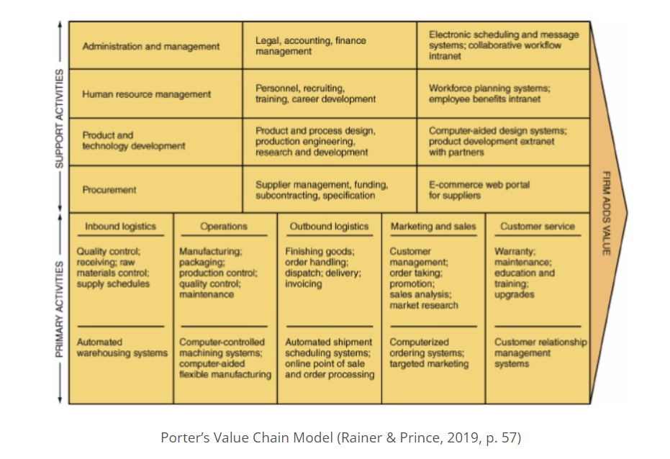

## 4.1 Recommendation 1

## 4.2 Recommendation 2

## 4.3 Recommendation 3

# 5. Conclusion (maximum 200 words)

Discuss the actions that the Sneaker Company or retailer should engage in so as to increase sales and engage more actively with its customer base in the purchase of ecofriendly and sustainable products. What other types of social media (based upon research) should be introduced to the company or retailer? (200 words at max)

# 6. Recommendations (maximum 150 words)

Make three recommendations to the Sneaker brand on how the company can enhance or maximise the value offered to ‘customers’ by producing more ethical sneakers and delivering a strong message via Social Media and their official website. (150 words max)

## **6.1** Recommendation 1

## **6.2** Recommendation 2

## **6.3** Recommendation 3

# 7. References

Sample for you to begin:

Quesenberry, K. A. (2015). Conducting a Social Media Audit. Harvard Business Review, 18, 1-6.

Rainer, K. R., & Prince, B. (2019). *Introduction to Information Systems* (pp. 12-17) (7th ed.). USA: John Wiley & Sons. Retrieved from <https://ebookcentral-proquest-com.ezproxy.laureate.net.au/lib/think/detail.action?docID=5633337&ppg=10>

*This section does not add to your word count*

*Minimum of 10 references with at least 5 academic references.*

*Not included in word count*

*Must be in alphabetical order*

*APA style reference list is not numbered*

*APA 7th Edition Referencing Style*

*Starts on a new page separate from your report*

***Other information – Referencing tips***

*Note: The course modules have a number of references providing background information about key concepts you will cover that you are able to use for this section. There will be other references on the course slides that you can use. In addition, you can go to the Torren Library and find more information to support your work.* [*https://library.torrens.edu.au/home*](https://library.torrens.edu.au/home)

[*https://library.torrens.edu.au/academicskills/home*](https://library.torrens.edu.au/academicskills/home)

*https://library.torrens.edu.au/academicskills/apa/tool*

*You can find out statistics about many companies through the following sites:*

[*https://www.statista.com/*](https://www.statista.com/)

[*https://www.ibisworld.com/*](https://www.ibisworld.com/) *- to get access to reports you can access this through the Torrens Library. For assistance on this ask the Librarians through the Library Chat.*

*Diagrams & Images are to be sourced and referenced. This is a very visual assignment.*

# 8. *Appendices*

*You may have additional material to support your case that you include in this section. This does not add to your word count.*

**IMPORTANT NOTES:**

*Remember to always use the third person when writing a business report-*

*EG. The researcher/s, the team, the investigator/s, the author/s…. Never use I, we etc.)*

*Save drafts, notes and sources used to prepare this assessment*

*Please submit ONE WORD DOCUMENT (.doc or .docx) via the MIS500 Assessment 1 Section*

*found in the Main navigation menu of the MIS500 Blackboard Site.*

*This Assessment should be 1000 words (+/-10%)*

*The Cover Page, Academic Integrity Declaration and References and the Table of Contents are not included in the word count.*

*Save file with the correct naming convention: …* *Please save your Assessment and submit it as the title of your submission using the following naming convention: subj code_M#_surname_first name initial_assessment title*

*E.g. MIS500_M1_Jones_S_Research Report*